NODE INTRODUCTION AND SAMPLE EXAMPLES
What is Node.js?
Node.js is a free, open source tool that lets you run JavaScript outside the web browser.
With Node.js, you can build fast and scalable applications like web servers, APIs, tools, and more.
What Can You Build With Node.js?
Node.js uses an event-driven, non-blocking model.
It can handle many connections at once without waiting for one to finish before starting another.
This makes it great for real-time apps and high-traffic websites.
Here are some examples of what you can build with Node.js:
- Web servers and websites
- REST APIs
- Real-time apps (like chat)
- Command-line tools
- Working with files and databases
- IoT and hardware control
| Port | Usage |
| ------| ------------------------------------ |
| 3000 | Most commonly used for Node.js |
| 4000 | Development |
| 5000 | APIs |
| 8000 | Testing |
| 8080 | Alternative HTTP port |
| 4200 | Angular |
| 5173 | Vite |
| 27017 | MongoDB (do NOT use for Node server) |

How to Run Node.js Code
node app.js

1.Sample Nodejs example program using html-Type the program in vs code fimename as demo1.js
var http = require("http");
var fs = require("fs");
http.createServer(function (req, res) {

fs.readFile("indexpage.html", function (err, data) {
res.writeHead(200, { "Content-Type": "text/html" });
res.write(data);
return res.end();
});
}).listen(3000);
console.log("Server running at http://localhost:3000");

indexpage.html
<!DOCTYPE html>
<html>
<head>
<title>Node Demo</title>
<link rel="stylesheet" href="style.css">
</head>
<body>
<h1>Node.js File Reading Example</h1>
<p>This page is loaded using fs module.</p>
</body>
</html>
Output: locate in nodejs command prompt environment after installation nodejs- available in gogole –(open source)
C:\Users\maste\demo1>node demo1
Server running at http://localhost:3000

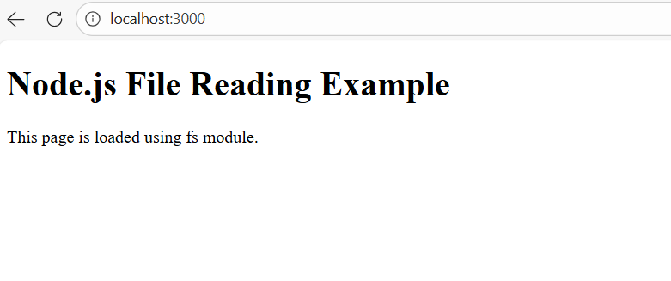
2.Sample Nodejs example program using css—Type the program in vs code- filename as demo1.js
var http = require("http");
var fs = require("fs");

http.createServer(function (req, res) {

fs.readFile("style.css", function (err, data) {
res.writeHead(200, { "Content-Type": "text/css" });
res.write(data);
return res.end();
});

}).listen(3000);

console.log("Server running at http://localhost:3000");

Styles.css
/* Page styling */
body {
background-color: #e8f0fe;
font-family: Arial, Helvetica, sans-serif;
text-align: center;
margin-top: 80px;
}

/* Heading style */
h1 {
color: #0b3d91;
font-size: 32px;
}

/* Paragraph style */
p {
font-size: 18px;
color: #333333;
}

/* Box design */
.container {
width: 60%;
margin: auto;
padding: 25px;
background-color: white;
border-radius: 10px;
box-shadow: 0px 0px 10px gray;
}

Output:
C:\Users\maste\demo1>node demo1
Server running at http://localhost:3000 // copy and paste in the browser->executes the output
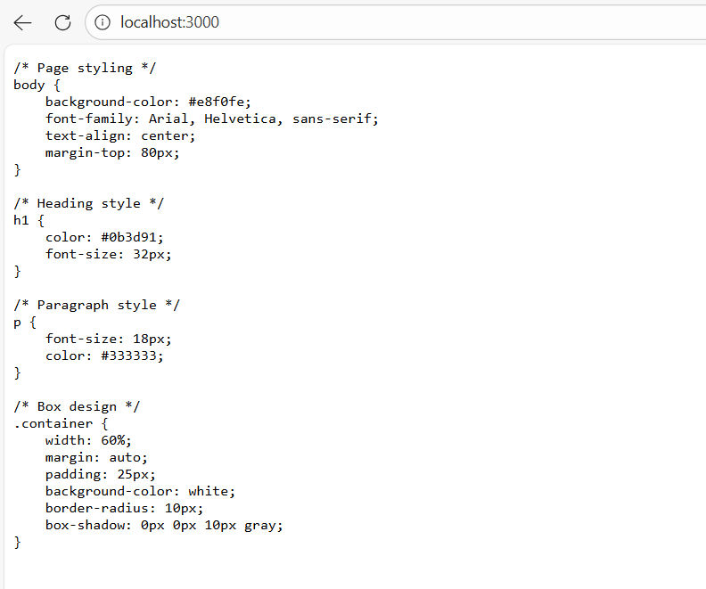
3.Nodejs using html and css---Type the program in vs code—in the file name demo1.js
var http = require("http");
var fs = require("fs");
var path = require("path");
http.createServer(function (req, res) {

// default page
var filePath = "." + req.url;

if (filePath == "./") {
filePath = "./indexpage.html";
}

// find file extension
var ext = path.extname(filePath);

var contentType = "text/html";

if (ext == ".css") {
contentType = "text/css";
}

fs.readFile(filePath, function (err, data) {

if (err) {
res.writeHead(404);
res.end("File not found");
} else {
res.writeHead(200, { "Content-Type": contentType });
res.write(data);
res.end();
}
});

}).listen(3000);

console.log("Server running at http://localhost:3000");

indexpage.html
<!DOCTYPE html>
<html>
<head>
<title>Node Demo</title>
<link rel="stylesheet" href="style.css">
</head>
<body>
<h1>Node.js File Reading Example</h1>
<p>This page is loaded using fs module.</p>
</body>
</html>

Styles.css
/* Page styling */
body {
background-color: #e8f0fe;
font-family: Arial, Helvetica, sans-serif;
text-align: center;
margin-top: 80px;
}

/* Heading style */
h1 {
color: #0b3d91;
font-size: 32px;
}

/* Paragraph style */
p {
font-size: 18px;
color: #333333;
}

/* Box design */
.container {
width: 60%;
margin: auto;
padding: 25px;
background-color: white;
border-radius: 10px;
box-shadow: 0px 0px 10px gray;
}
Output:
C:\Users\maste\demo1>node demo1
Server running at http://localhost:3000 //copy and paste in the browser
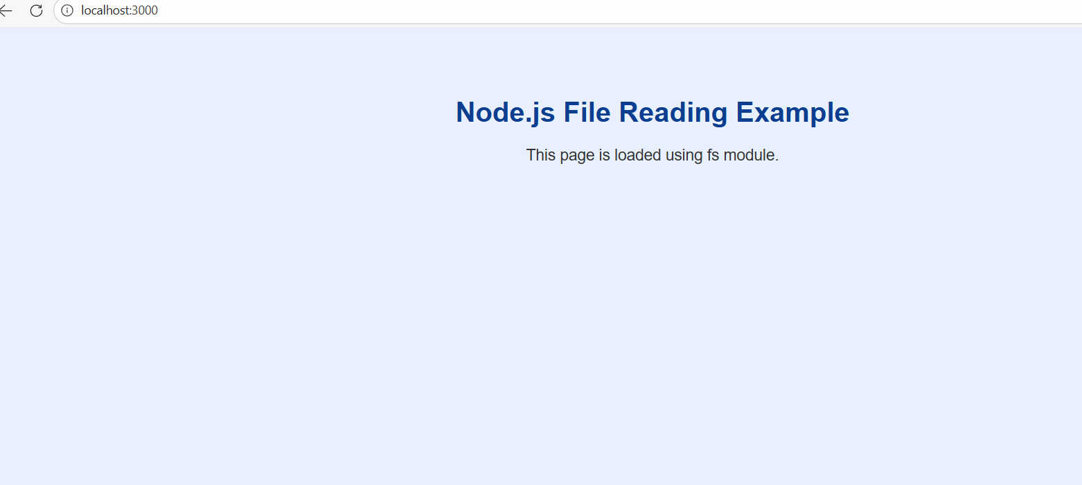

3.expressjs example program:

>npm install express

//Type the below program in vs code

const express=require('express');
const app=express();
const port = 5000; app.get('/',function(req,res)
{
res.json({title:'Hello world'})
})
app.get('/user',function(req,res)
{
res.json({fname:'Thiyagu',lname:'Rajan',age:'30'})
})
app.get('/users',function(req,res)
{
res.json([{fname:'Usama',lname:'Akram',age:'22'},{fname:'Laksi',lname:'Rishi', age:'5'}])
})
app.listen(port, () => console.log(`Example app listening at http://localhost:${port}`))

Output:

C:\Users\maste\demo>node expressdemo.js
Example app listening at http://localhost:5000
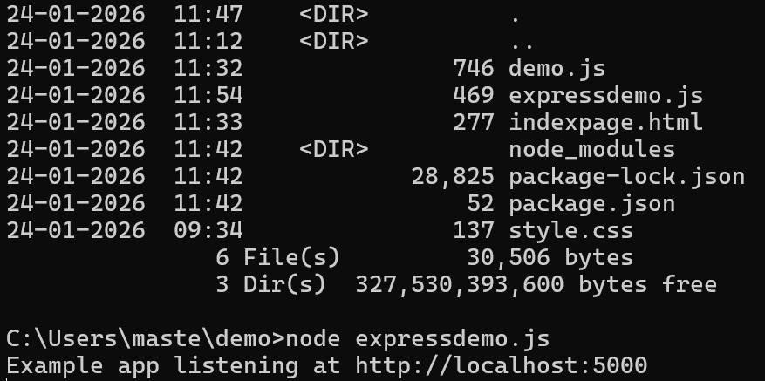

Locate the output in the browser http://localhost:5000

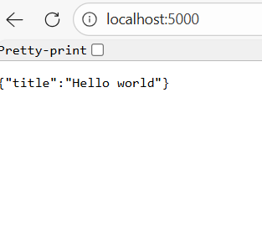

Locate the output in the browser http://localhost:5000/user
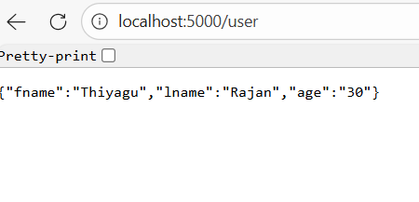
Locate the output in the browser http://localhost:5000/users

